
QUALITY ALERT

Customer: AVANTI Date: April 30, 2025
Die: 15036 Colour: ALL
Type of Complaint: REJECTED

Q.A # Q.I.R # CUSTOMER NCR #

Description: Customer REJECTED because of deformed weatherstrip pocket.
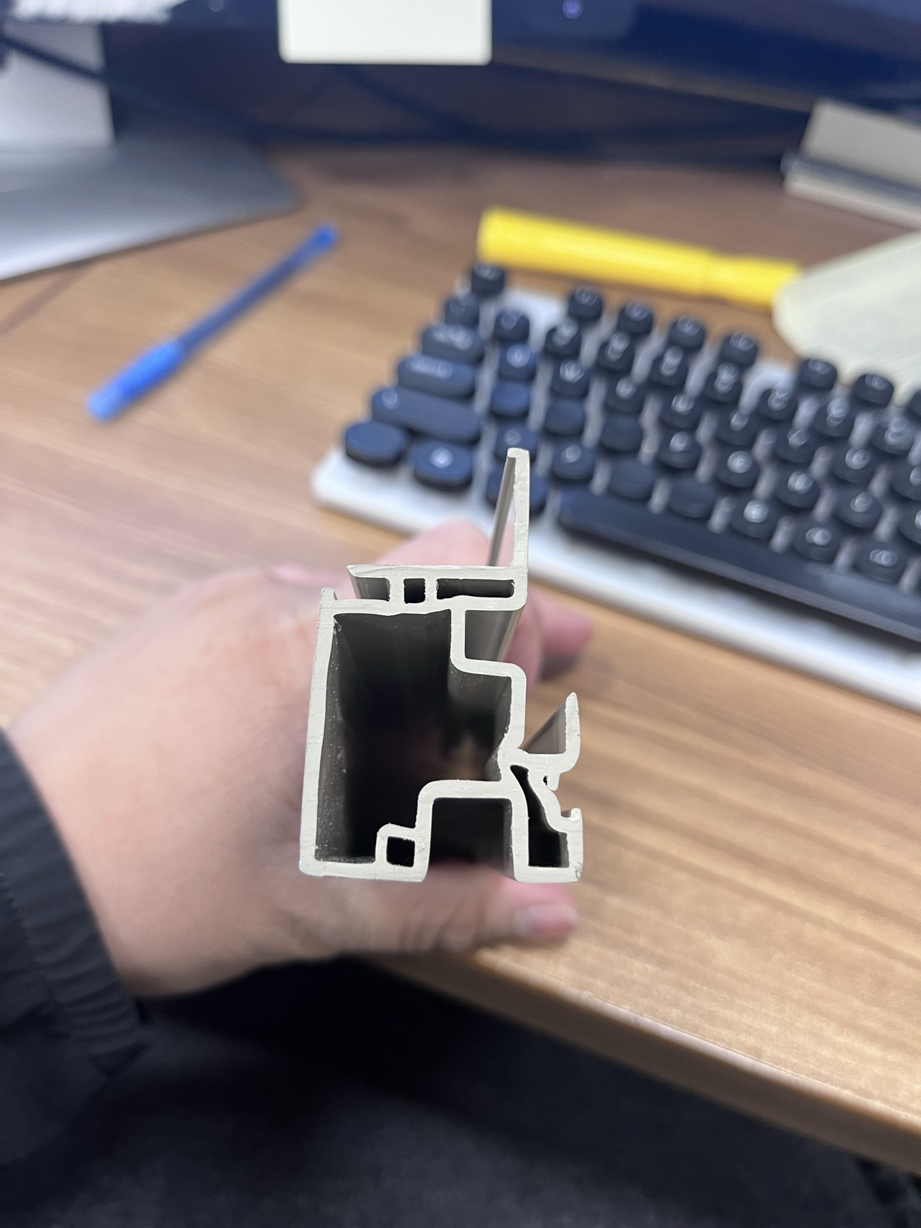
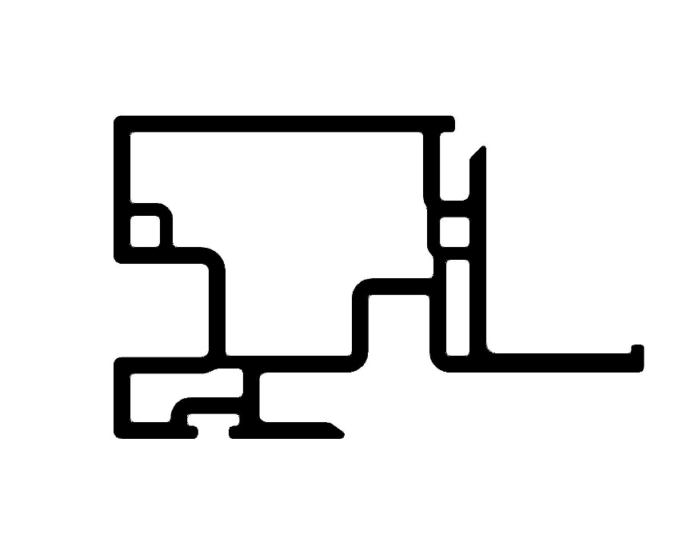




PLEASE MAKE SURE MATERIAL IS IN GOOD SHAPE BEFORE PACKING

BY SIGNING BELOW, YOU ACKNOWLEDGE THE PROBLEM ABOVE AND AGREE TO MONITOR THIS ISSUE IN FUTURE PRODUCTION RUNS.
DAY SHIFT |  | AFTERNOON SHIFT |  | NIGHT SHIFT
NAME | SIGNATURE | NAME | SIGNATURE | NAME | SIGNATURE

